**Assignment 4.3**

**Ques:1. States = rownames(US Arrests)**

**Get states names with ‘w’.**

**Get states names with ‘W’.**

**Ans:-**

|  |
| --- |
| > USArrestsnames<-data.frame(USArrests$X)  > USArrestsnames  USArrests.X  1 Alabama  2 Alaska  3 Arizona  4 Arkansas  5 California  6 Colorado  7 Connecticut  8 Delaware  9 Florida  10 Georgia  11 Hawaii  12 Idaho  13 Illinois  14 Indiana  15 Iowa  16 Kansas  17 Kentucky  18 Louisiana  19 Maine  20 Maryland  21 Massachusetts  22 Michigan  23 Minnesota  24 Mississippi  25 Missouri  26 Montana  27 Nebraska  28 Nevada  29 New Hampshire  30 New Jersey  31 New Mexico  32 New York  33 North Carolina  34 North Dakota  35 Ohio  36 Oklahoma  37 Oregon  38 Pennsylvania  39 Rhode Island  40 South Carolina  41 South Dakota  42 Tennessee  43 Texas  44 Utah  45 Vermont  46 Virginia  47 Washington  48 West Virginia  49 Wisconsin  50 Wyoming  > USArrestsnames[grep("^w",USArrestsnames$USArrests),]  factor(0)  50 Levels: Alabama Alaska Arizona Arkansas California Colorado Connecticut Delaware Florida Georgia Hawaii Idaho Illinois Indiana Iowa ... Wyoming  > USArrestsnames[grep("^W",USArrestsnames$USArrests),]  [1] Washington West Virginia Wisconsin Wyoming  50 Levels: Alabama Alaska Arizona Arkansas California Colorado Connecticut Delaware Florida Georgia Hawaii Idaho Illinois Indiana Iowa ... Wyoming |
|  |
| |  | | --- | | > | |

**Ques:2.** **Prepare a Histogram of the number of characters in each US state.**

hist(USArrests$Murder , col = "red")

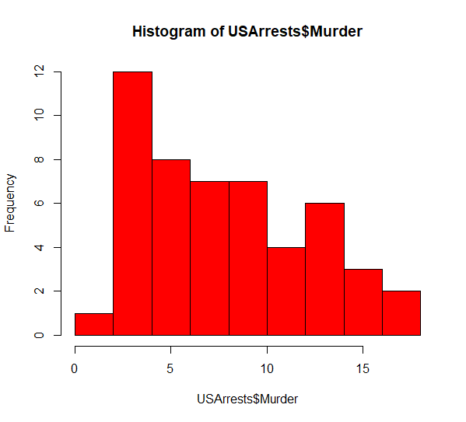

hist(USArrests$Assault , col = "blue") 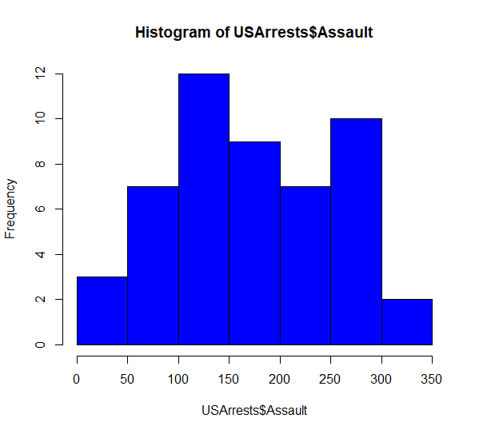

hist(USArrests$UrbanPop , col = "green") 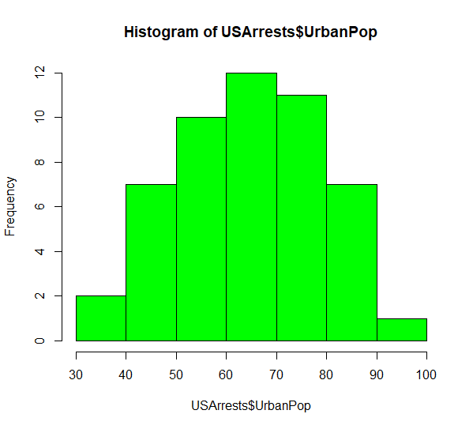

hist(USArrests$Rape , col = "brown") 